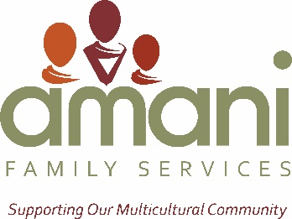
FOR IMMEDIATE RELEASE
For further information contact:

Irene Paxia
Amani Family Services, Inc.
ipaxia@amanifamilyservices.org
260-484-1414 x7
Community Foundation of Greater Fort Wayne Awards $25,000 Grant to Amani Family Services

Fort Wayne, IN (Sept. 30, 2016) – Amani Family Services has been awarded a grant in the amount of $25,000 by the Community Foundation of Greater Fort Wayne.

The Community Foundation grant will be used to support Amani’s mission of partnering with immigrant and refugee families and the community to promote safety, encourage personal growth, and foster a spirit of belonging.

“We are extremely grateful for the support of the Community Foundation. This grant allows us to continue our mission and support the operations of a growing agency”

Amani Family Services Inc. is a private nonprofit organization serving more than 500 families and individuals from around the world who have made Allen County their home. It’s one of the largest nonprofit agencies serving immigrants and refugees in the area, offering four programs, and employing approximately 45 multilingual staff members and contractors. Amani services include child abuse/neglect intervention and prevention, victim care, and counseling.

The Community Foundation of Greater Fort Wayne is a public charitable foundation serving Allen County since 1922. The Community Foundation had assets of approximately $140 million at December 31, 2015, and awarded more than $6.5 million in charitable grants and scholarships in that year. The Community Foundation of Greater Fort Wayne exists to serve as a community leader to improve the quality of life by building permanent endowments, promoting effective grantmaking, fostering philanthropy, stimulating community dialogue and helping donors achieve their charitable goals.

